Comp 8006 Assignment 3

Mat Siwoski

Shane Spoor

# Notes:

## Running the application:

To run the application, navigate to the folder that the script was installed to and type:

**sudo python3 a3_secure_log.py**

In the event that the file does not run:

**chmod +x a3_secure_log.py**

**chmod +x a3_secure_log.py**

to ensure that the file can be executed.

## Requirements:

The application has to follow the following requirements:

* Design, implement and test an application that will monitor the /var/log/secure file and detect password guessing attempts and then use iptables to block that IP.
* Your application will get user specified parameters (see constraints) and then continuously monitor the log file specified.
* As soon as the monitor detects that the number of attempts from a particular IP has gone over a user-specified threshold, it will generate a rule to block that IP.
* If the user has specified a time limit for a block, your application will flush the rule from Firewall rule set upon expiration of the block time limit.
* Design a test procedure that will test your application under a variety of conditions. For example, how will you handle a situation when an attacker sends a slow scan of your system, meaning several password guessing attempts, but spaced far enough apart in time so that your application will miss the attack.

## Constraints:

The application has to follow the following constraints:

* The application will be implemented using any scripting or programming language of your choice.
* The Firewall rules will be implemented using Netfilter.
* Your application will be activated through the crontab.
* Your application will obtain user input for the following parameters: The number of attempts before blocking the IP
  + The time limit for blocking the IP (Optional – bonus). The default setting will be block indefinitely.
  + Monitor a log file of user’s choice (Optional - bonus).Keep in mind that different log files have different formats.

# Design:

## Design Diagrams

Comp8006-Assn3.png

## Pseudocode:

check_for_failed_password  
 Go through each line  
 If “Failed password for” is found  
 Send to record_operations  
 Else   
 Continue

Scan_var_log  
 If mod_time is equal  
 Continue  
 Else  
 If Open File  
 Read Lines  
 Send to check_for_failed_password  
 Else  
 Send Error

Main

scan_var_log  
 exit()

record_operations  
 Split data for date  
 Split data for IP, Port, User & Connection  
 Check to see if user has reached threshold,   
 if true, add iptables rules and block the user

if( __main__)  
 If ubuntu  
 Use /var/log/auth.log  
 Else  
 Use /var/log/secure

# Test Results:

## 1.) Application in Crontab

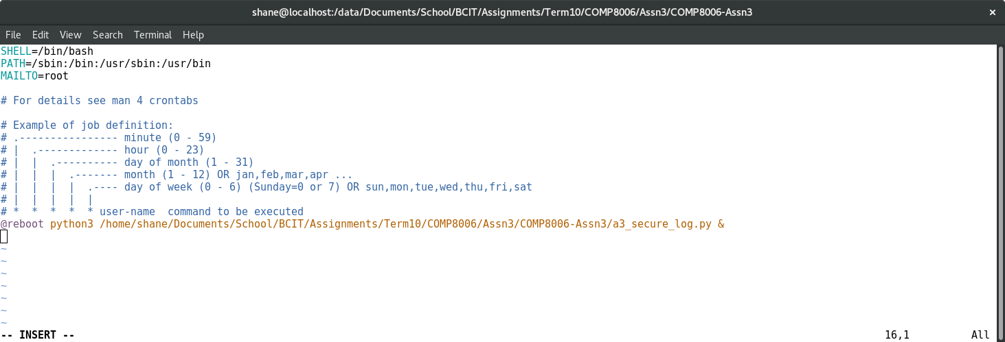

## 2.) Firewall rule inserted

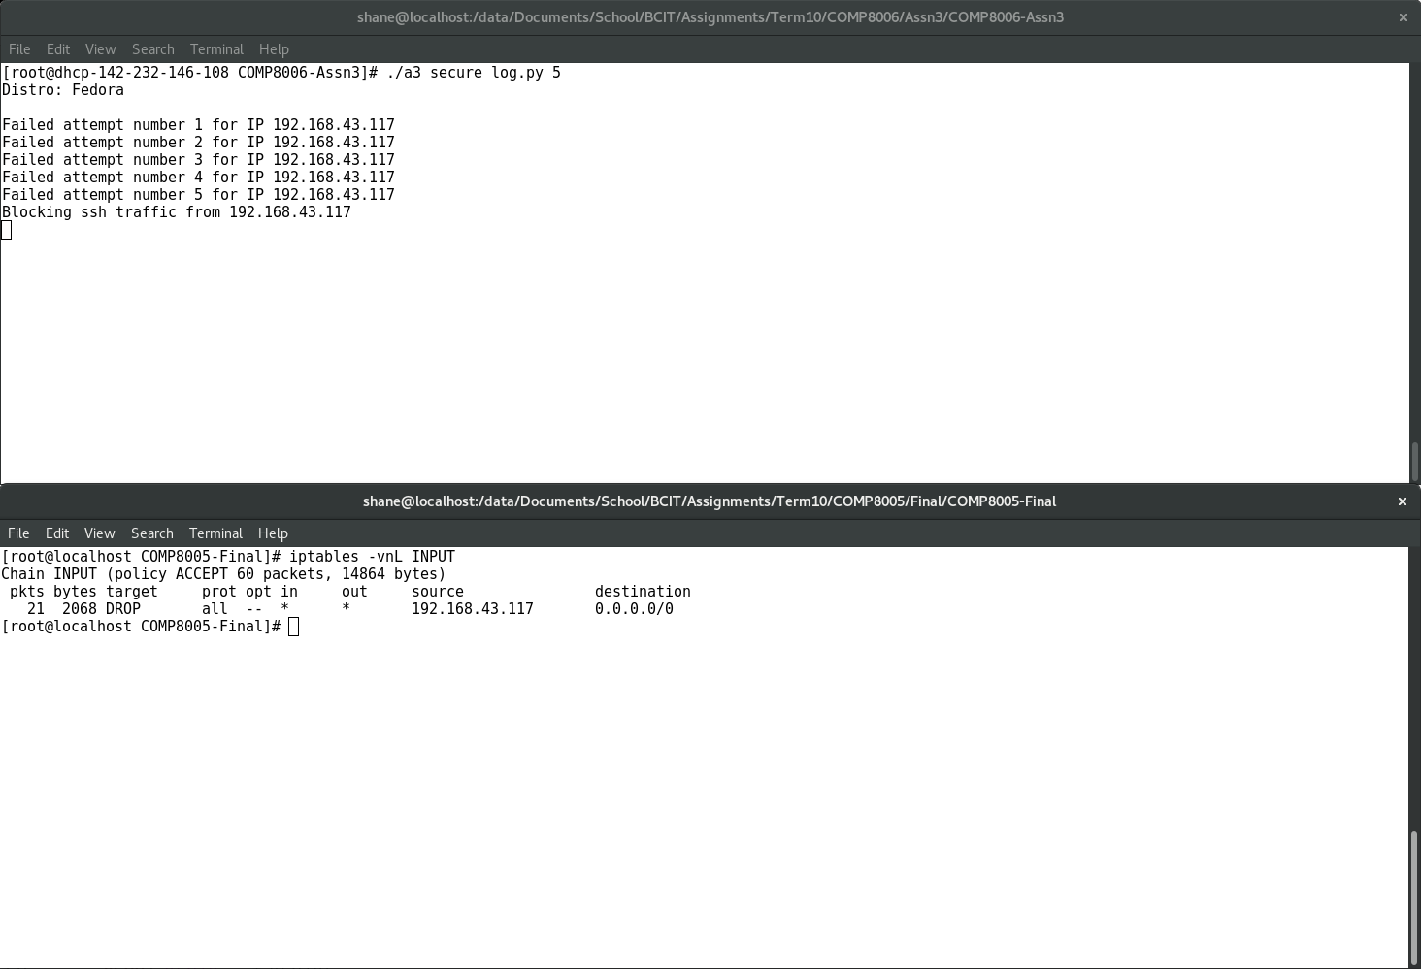

## 3.) Application detected failed password in file



## 4.) Blocked access to User

# 